Setra Power Battalion 48 Headstart PC Program Screenshot

3/24/2018 Ben Lin

Opening Screen

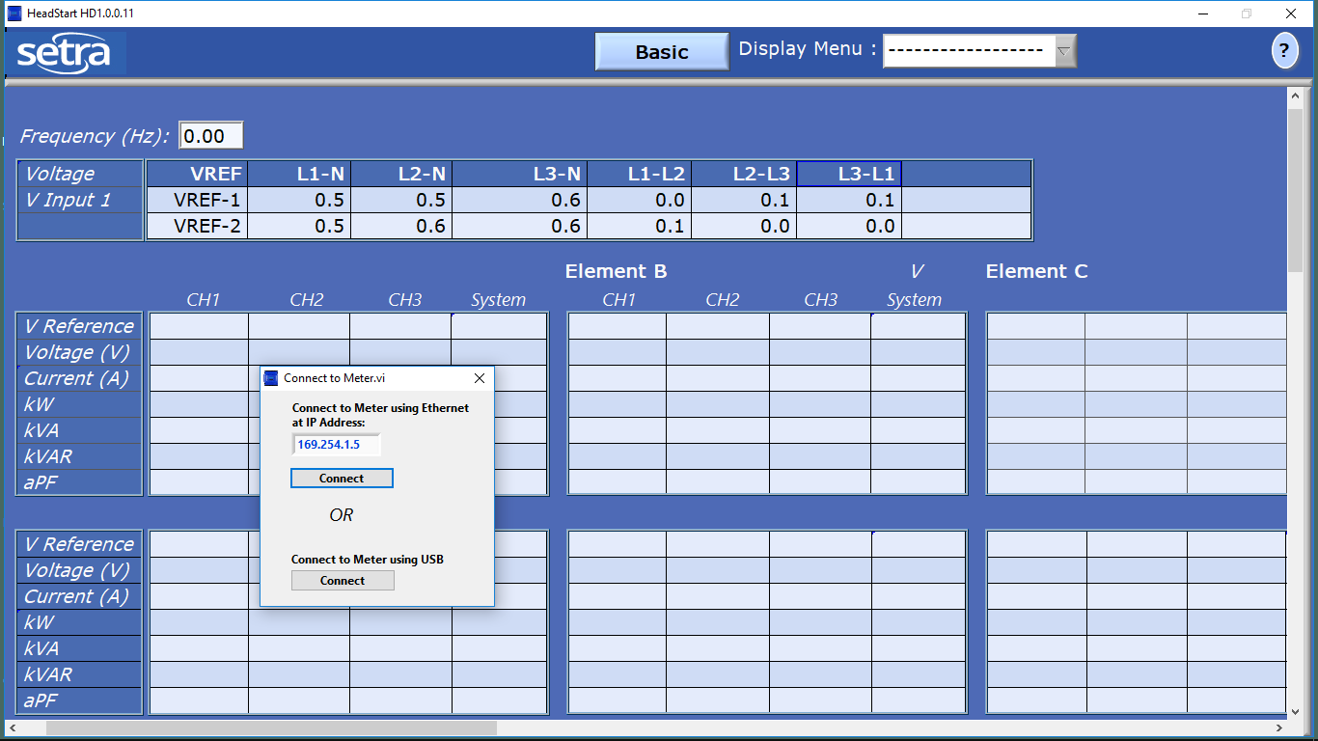

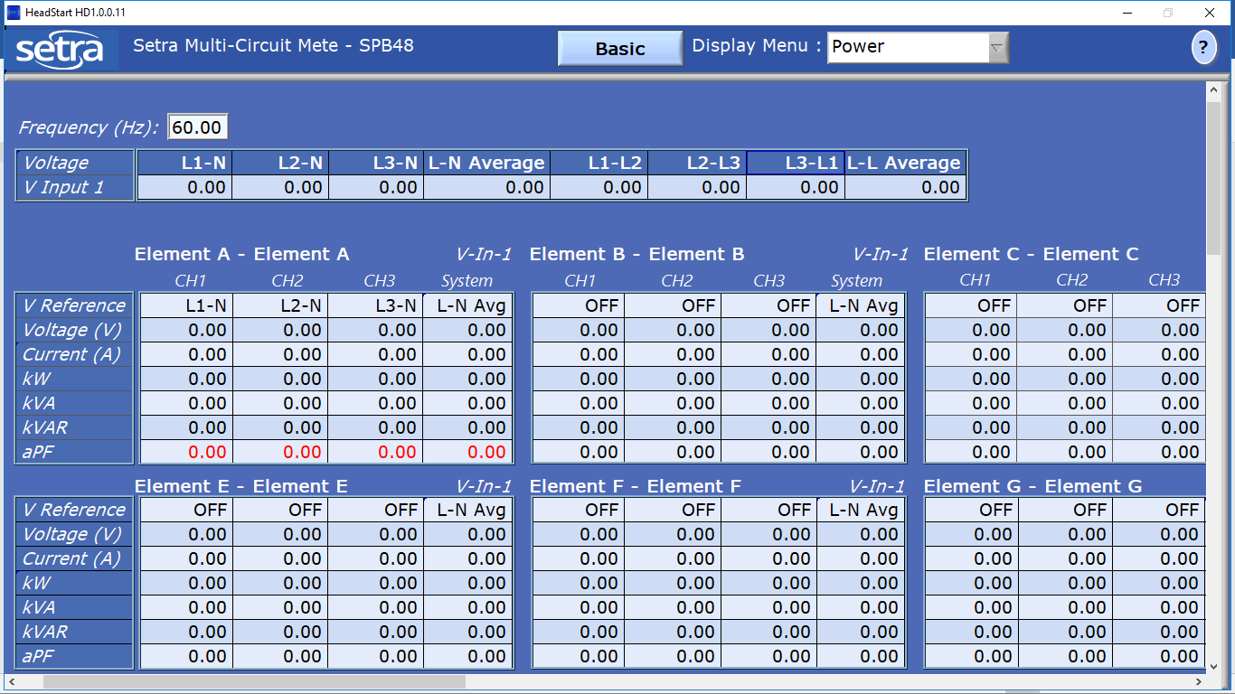

Basic – Display Menu Selection

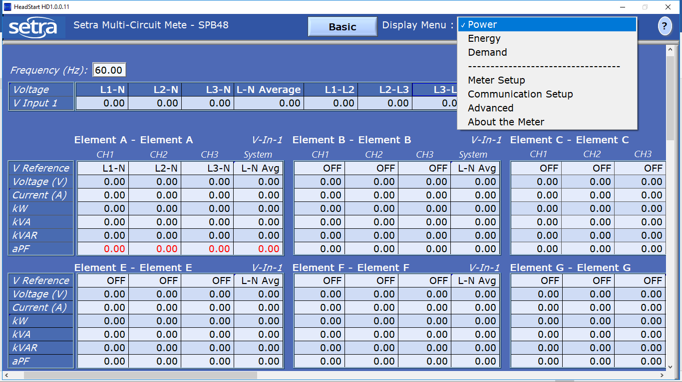

Extended – Display Menu Selection

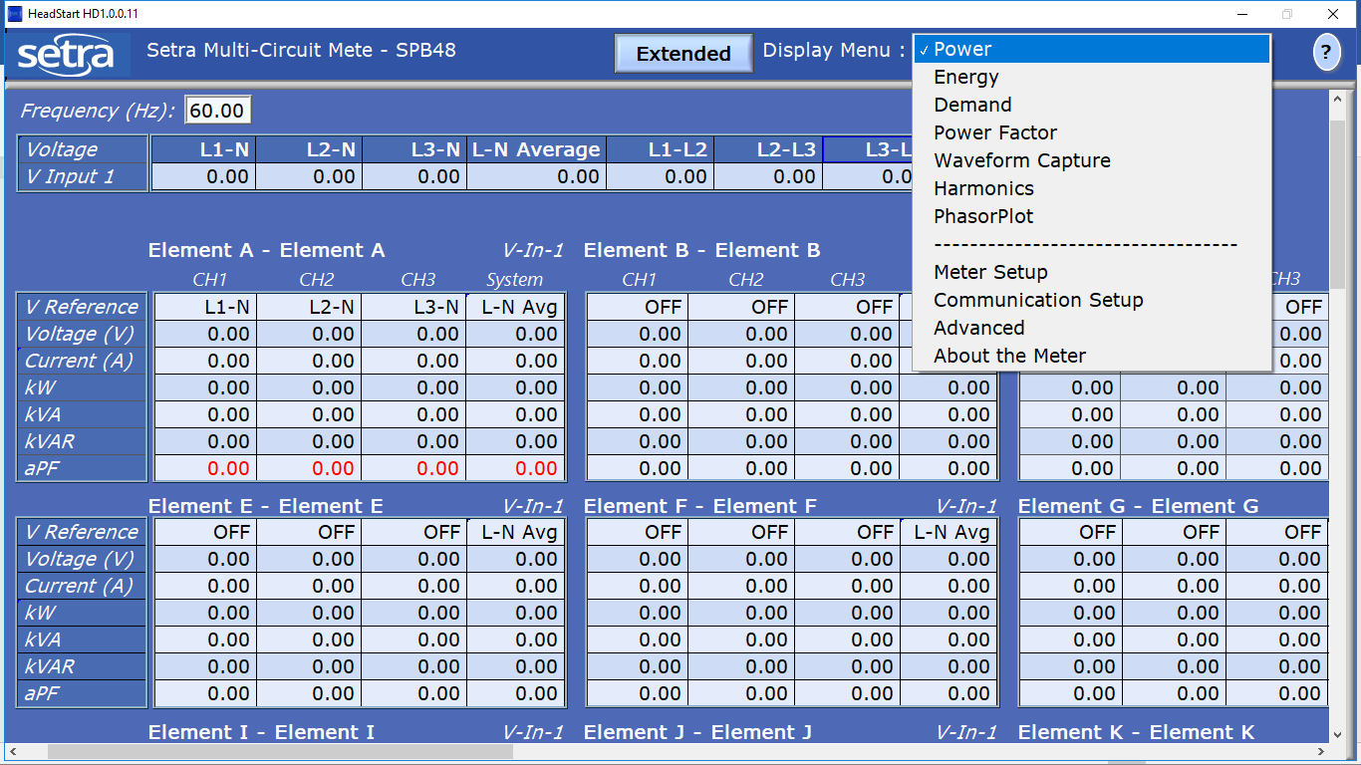

Basic > Power

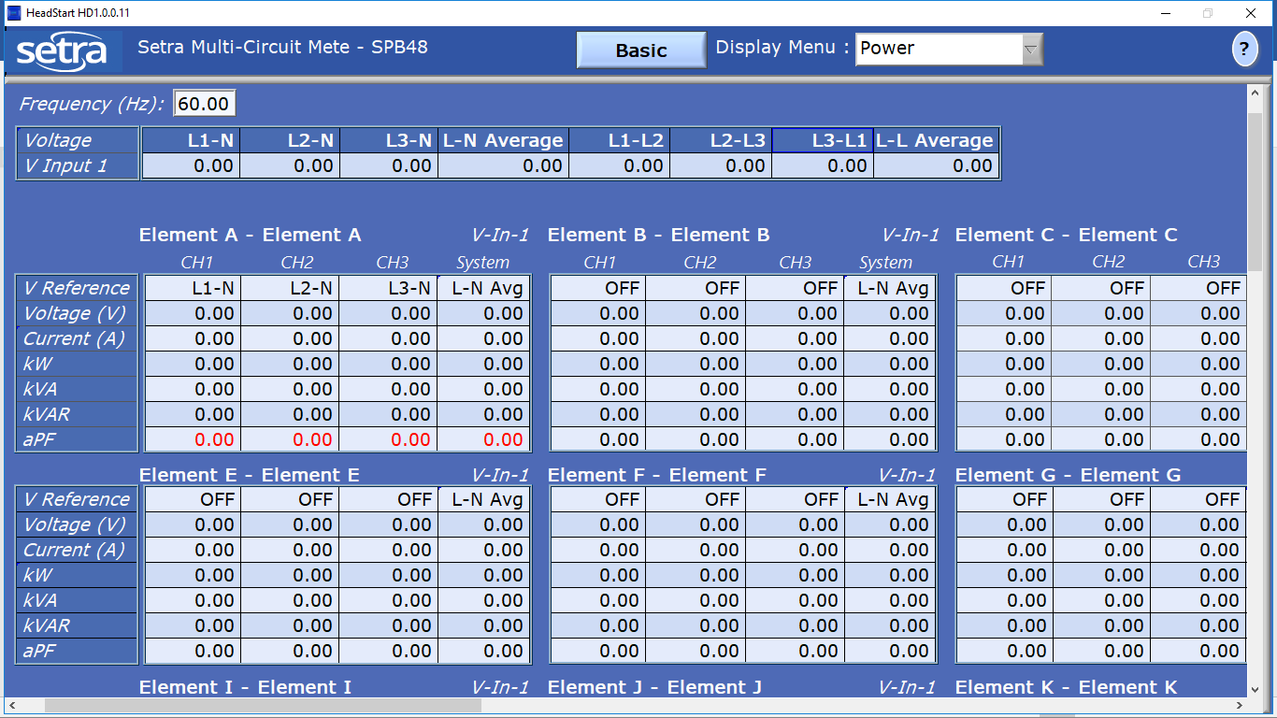

Basic > Energy

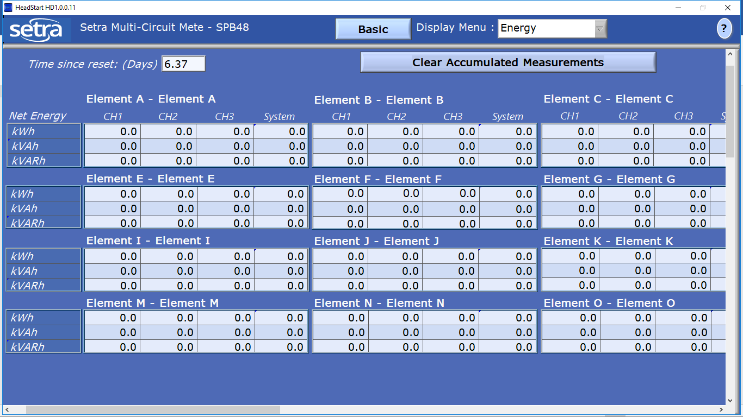

Basic > Demand

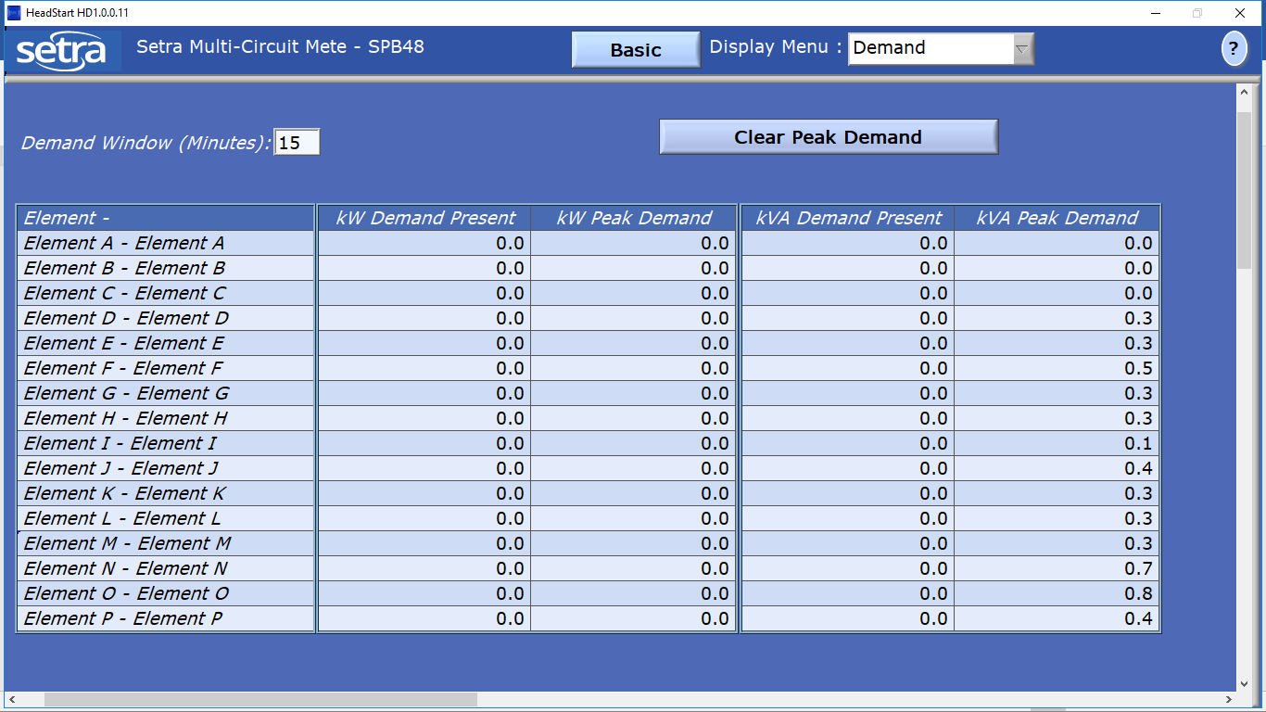

Basic > Meter Setup

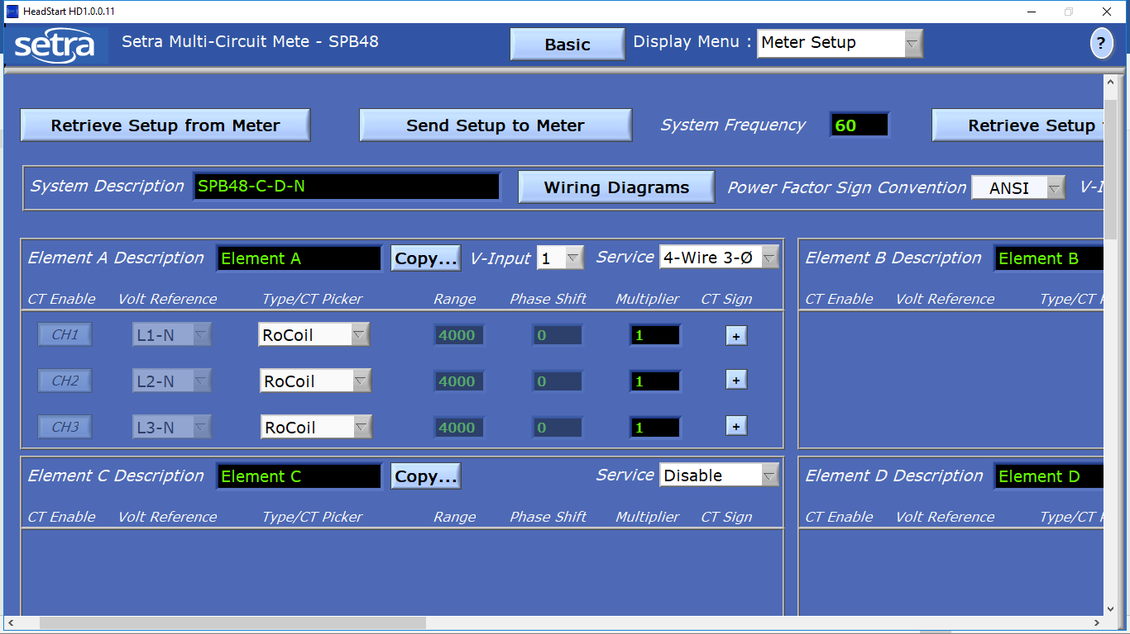

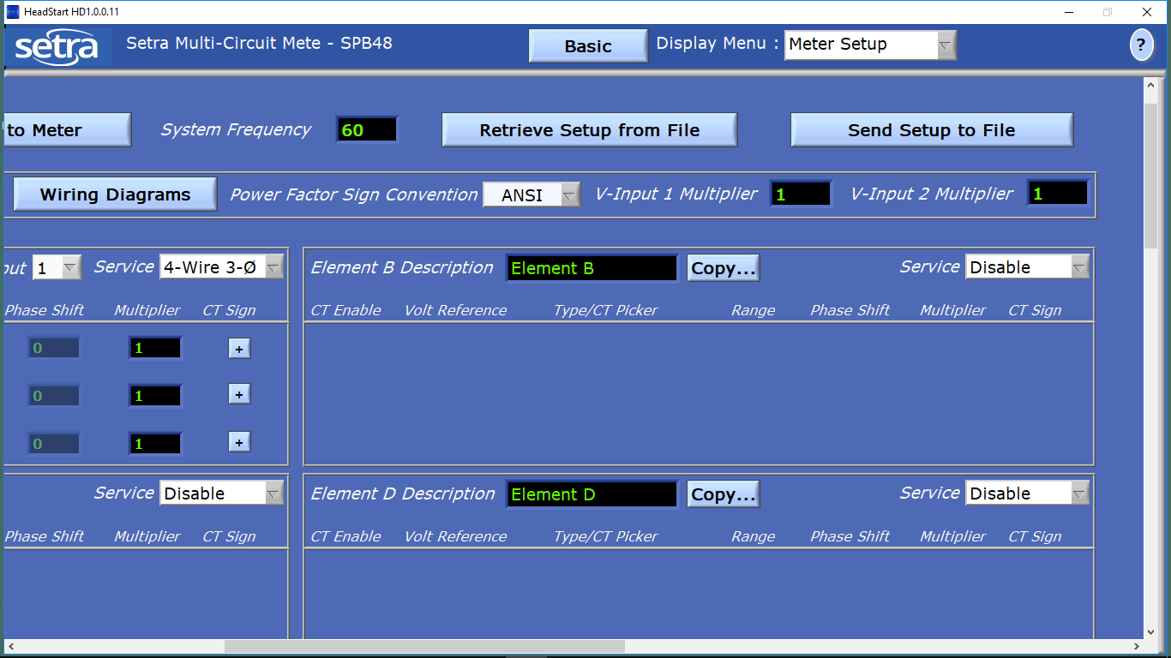

Basic > Meter Setup > Wiring Diagram

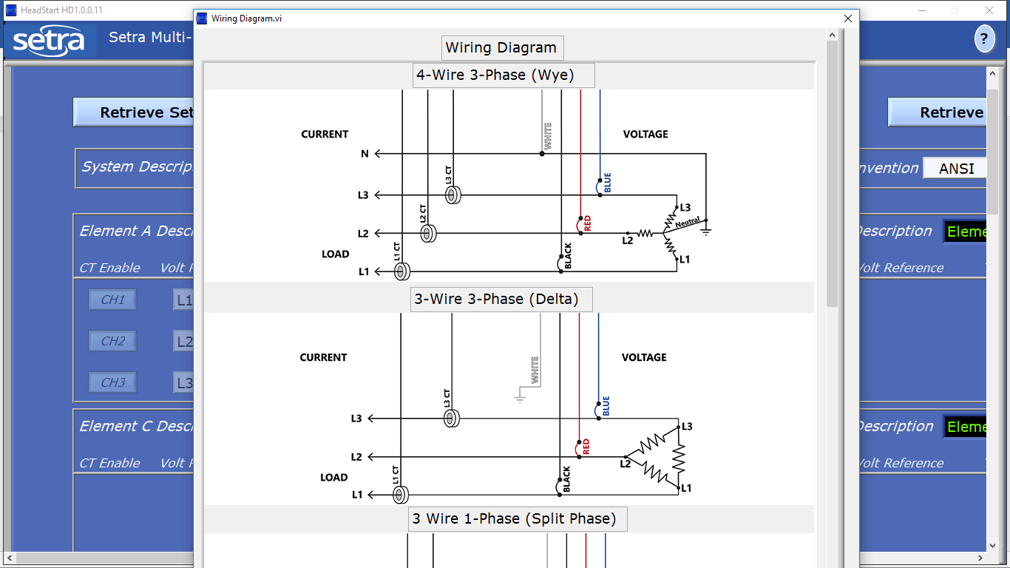

Basic > Meter Setup > Power Factor Sign Convention

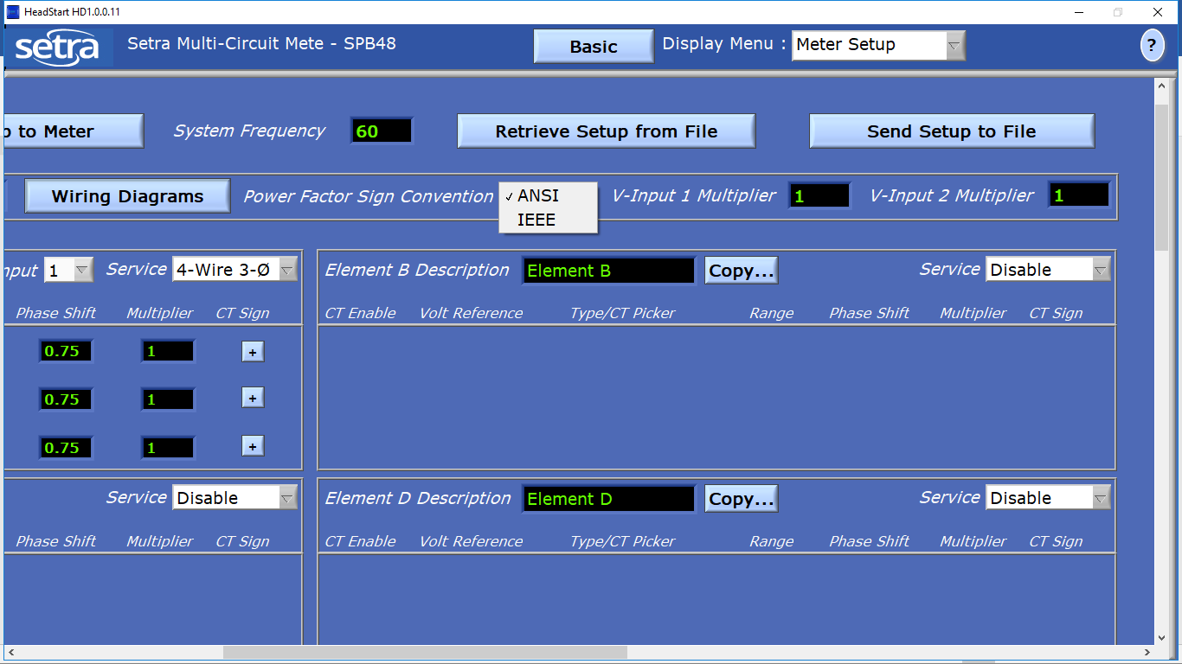

Basic > Meter Setup > V-Input

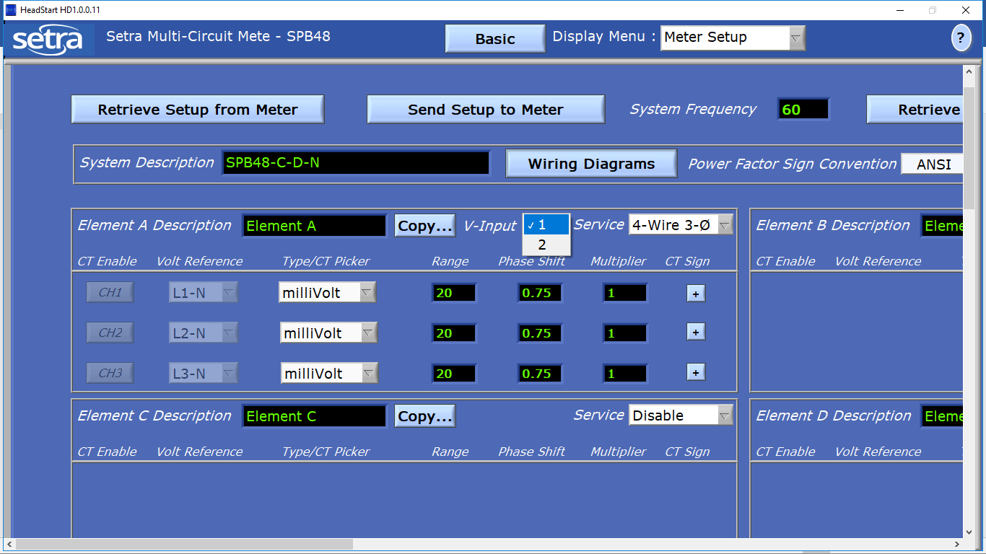

Basic > Meter Setup > Service

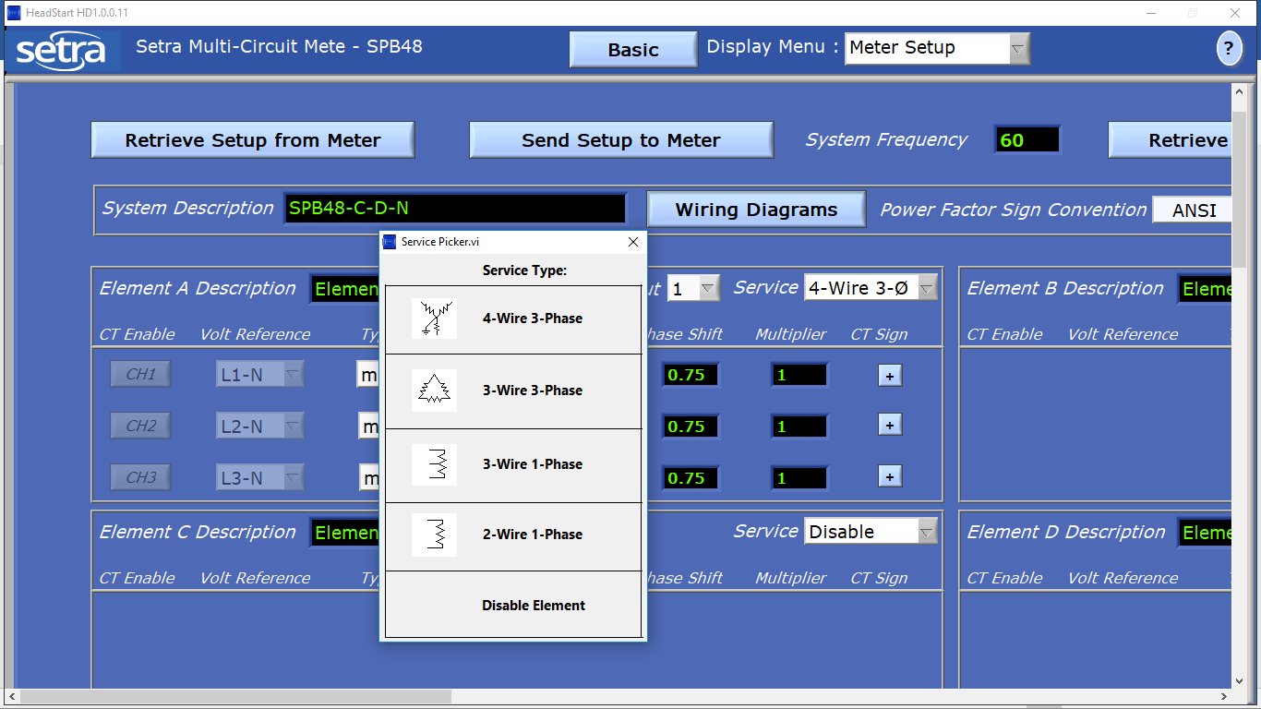

Basic > Meter Setup > Service > 4-Wire 3-Phase

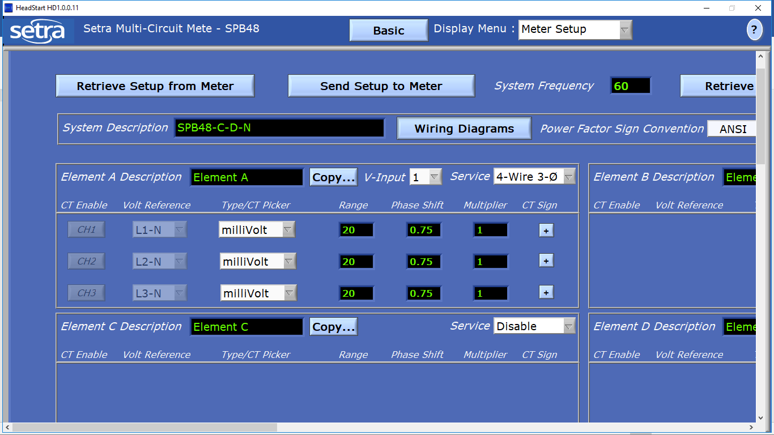

Basic > Meter Setup > Service > 3-Wire 3-Phase

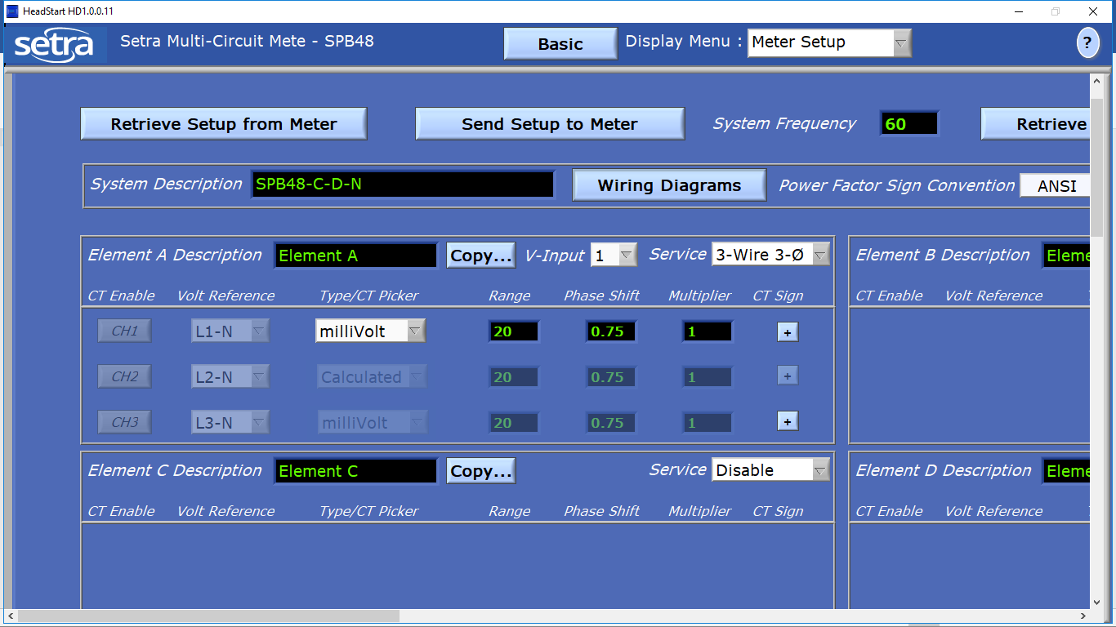

Basic > Meter Setup > Service > 3-Wire 1-Phase

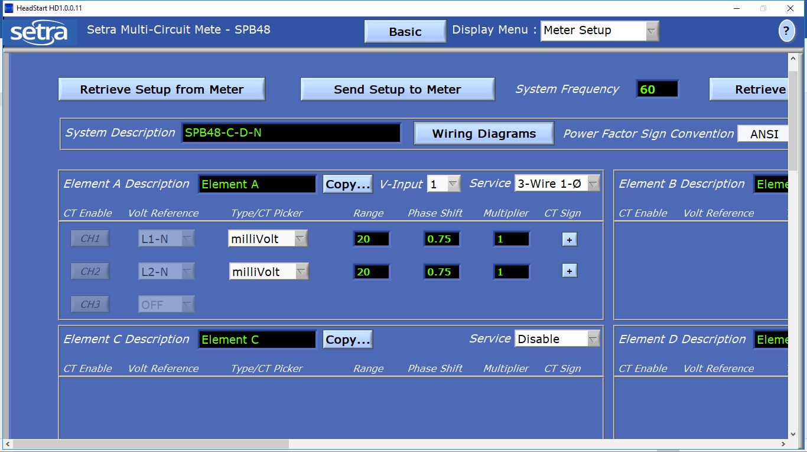

Basic > Meter Setup > Service > 2-Wire 1-Phase

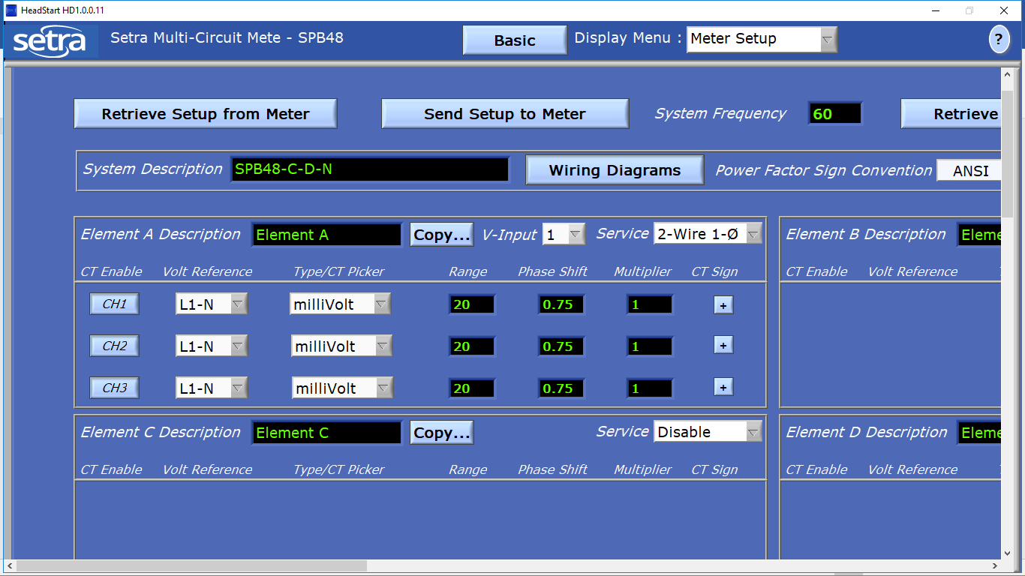

Basic > Meter Setup > Type/CT Picker

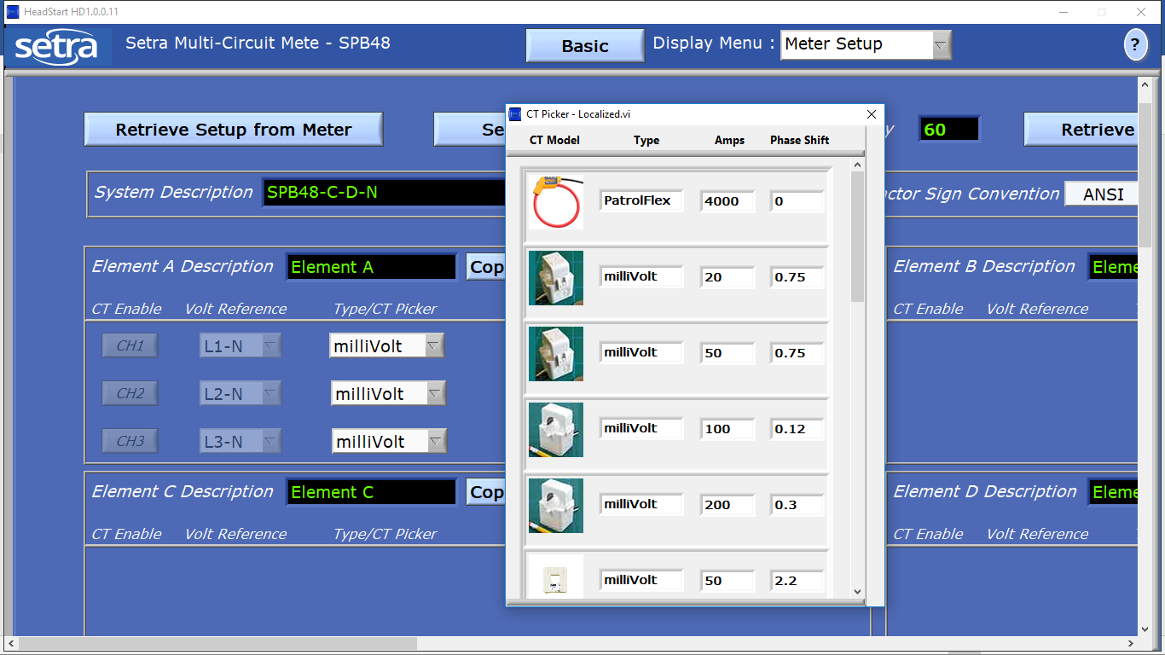

Basic > Meter Setup > Type/CT Picker > PatrolFlex

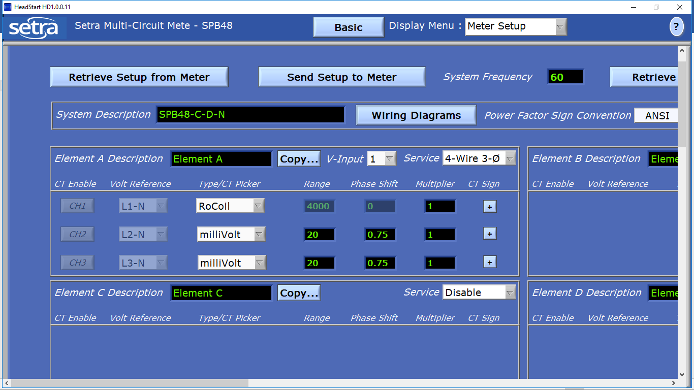

Basic > Meter Setup > Type/CT Picker > milliVolt 20A



Basic > Meter Setup > Type/CT Picker > milliVolt 200A

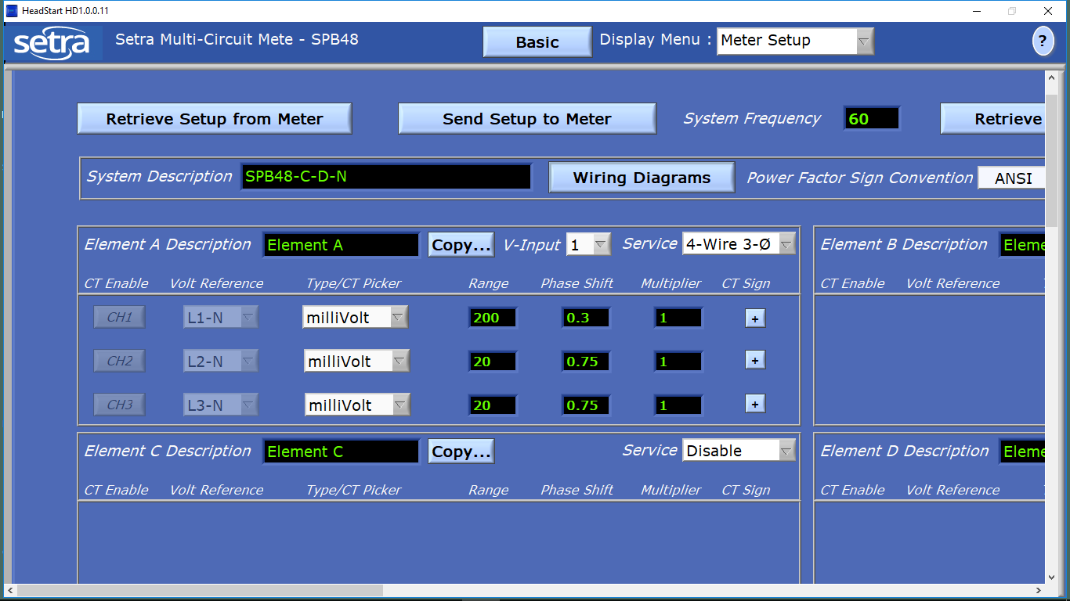

Basic > Meter Setup > CT Sign

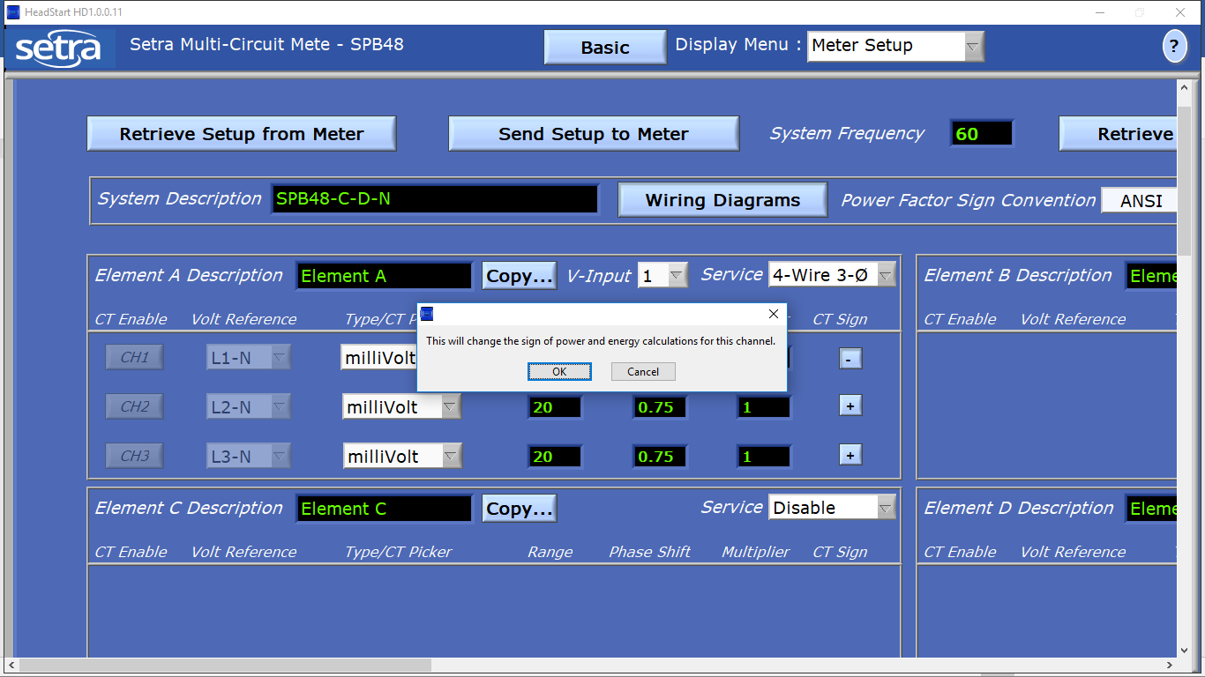

Basic > Meter Setup > Copy …

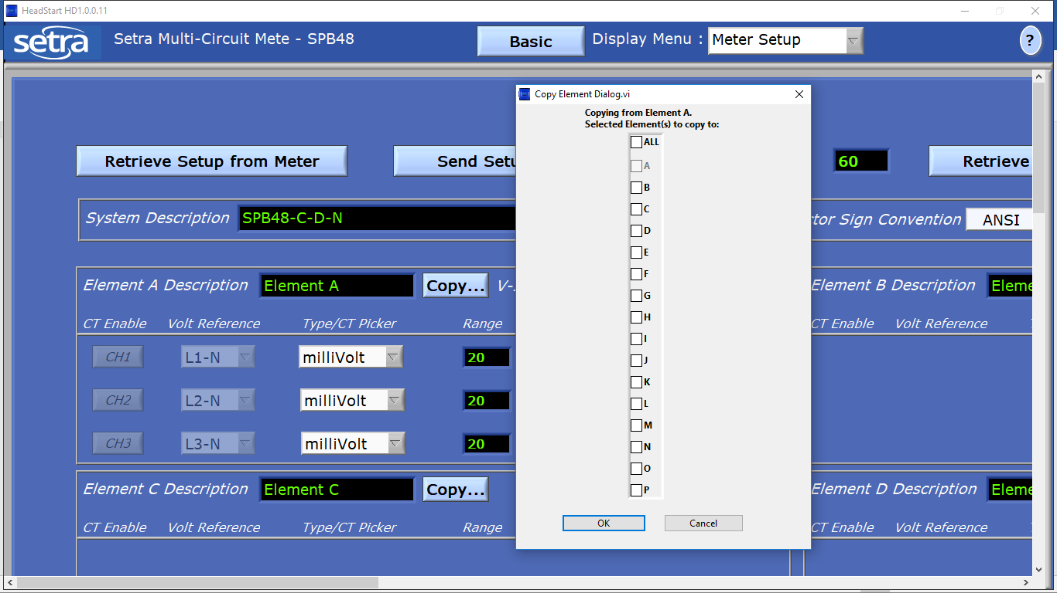

Basic > Communication Setup

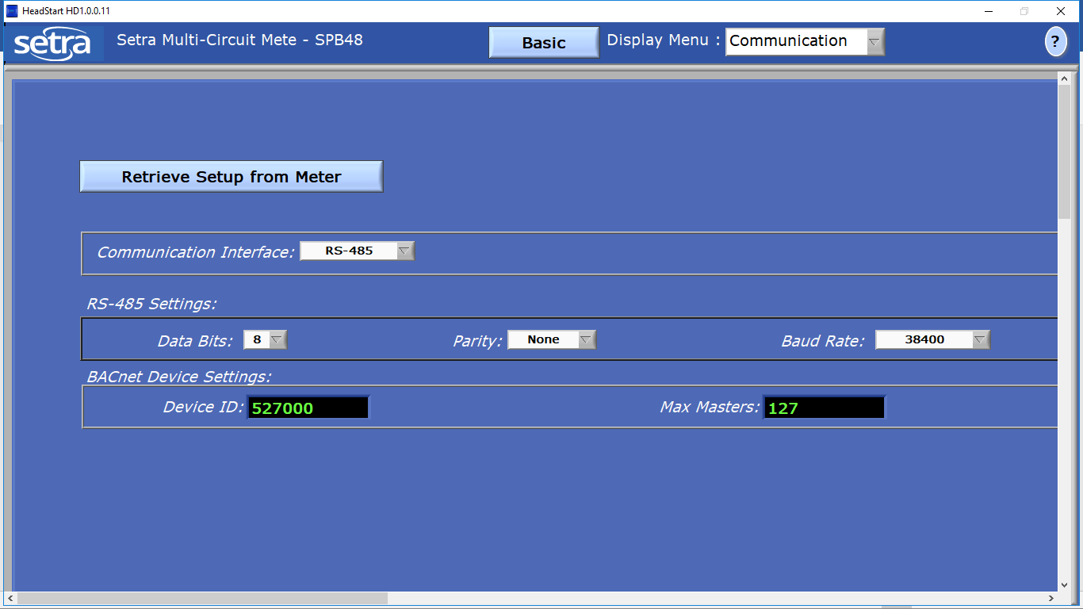

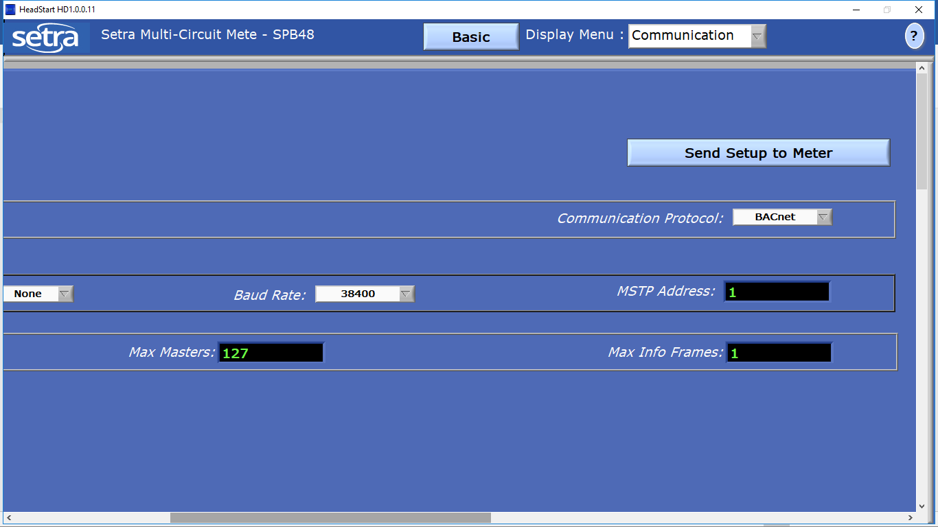

Basic > Communication Setup > Communication Interface

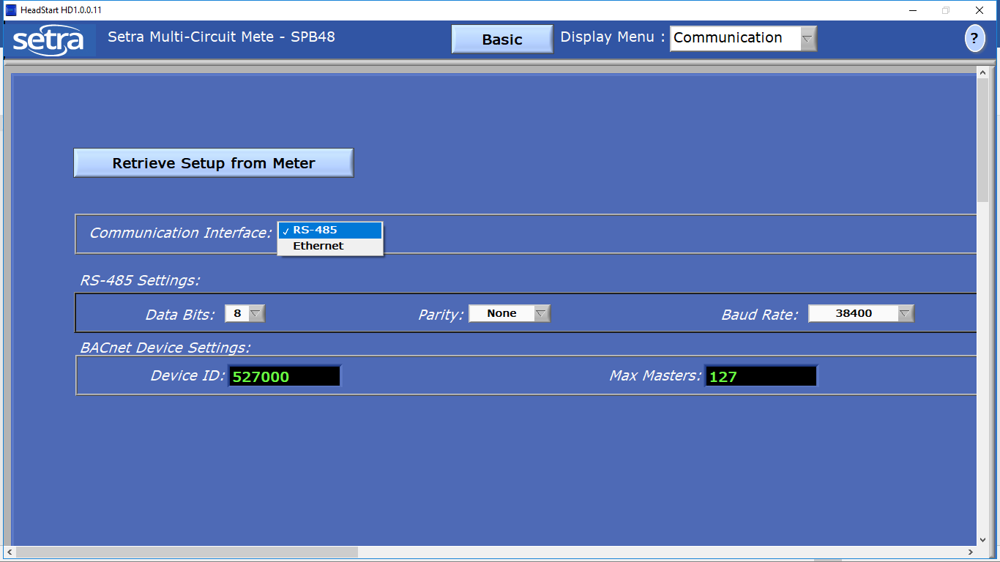

Basic > Communication Setup > Communication Interface > Baud Rate

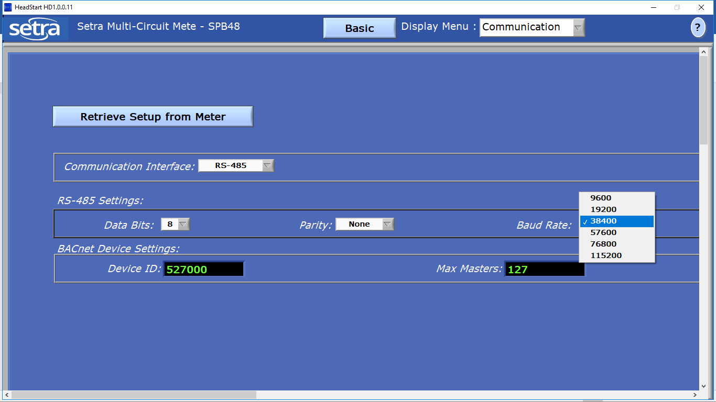

Basic > Communication Setup > Communication Protocol

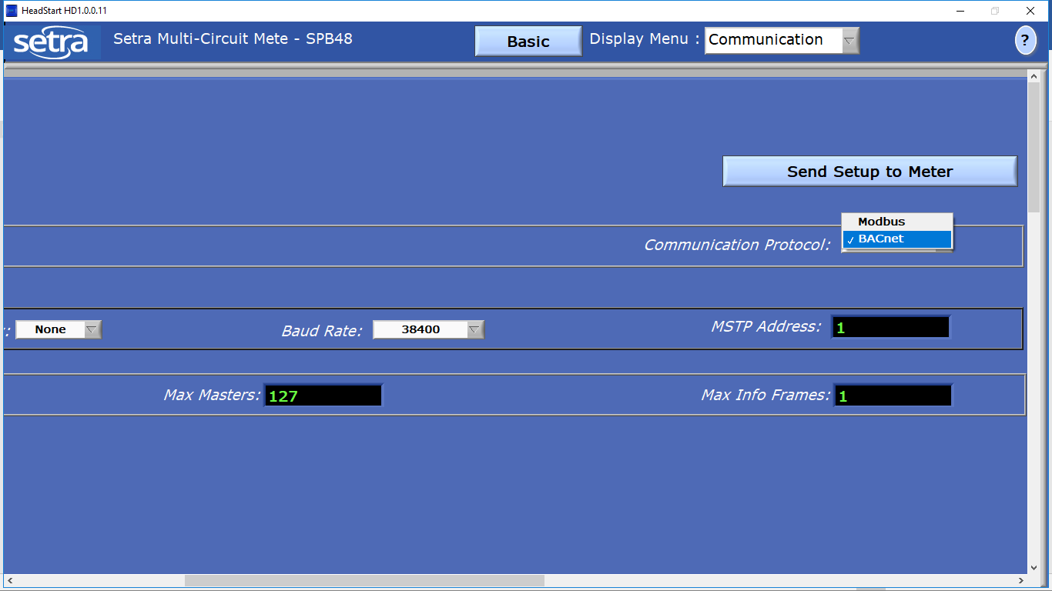

Basic > Communication Setup > Communication Protocol > Modbus

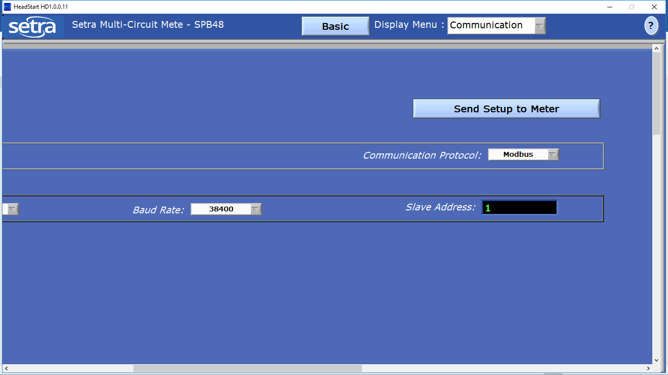

Basic > Communication Setup > Communication Interface > Ethernet (Modbus)

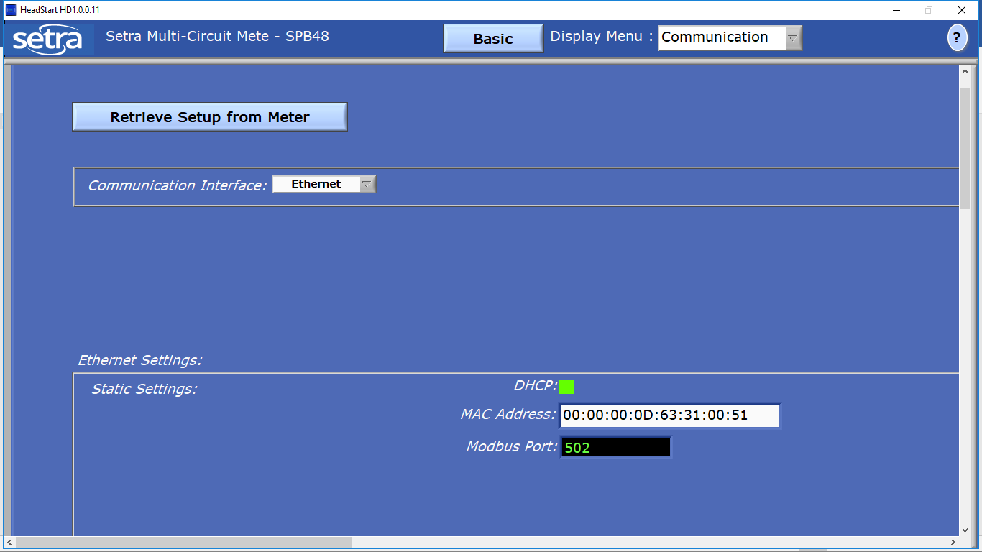

Basic > Communication Setup > Communication Interface > Ethernet (BACnet)

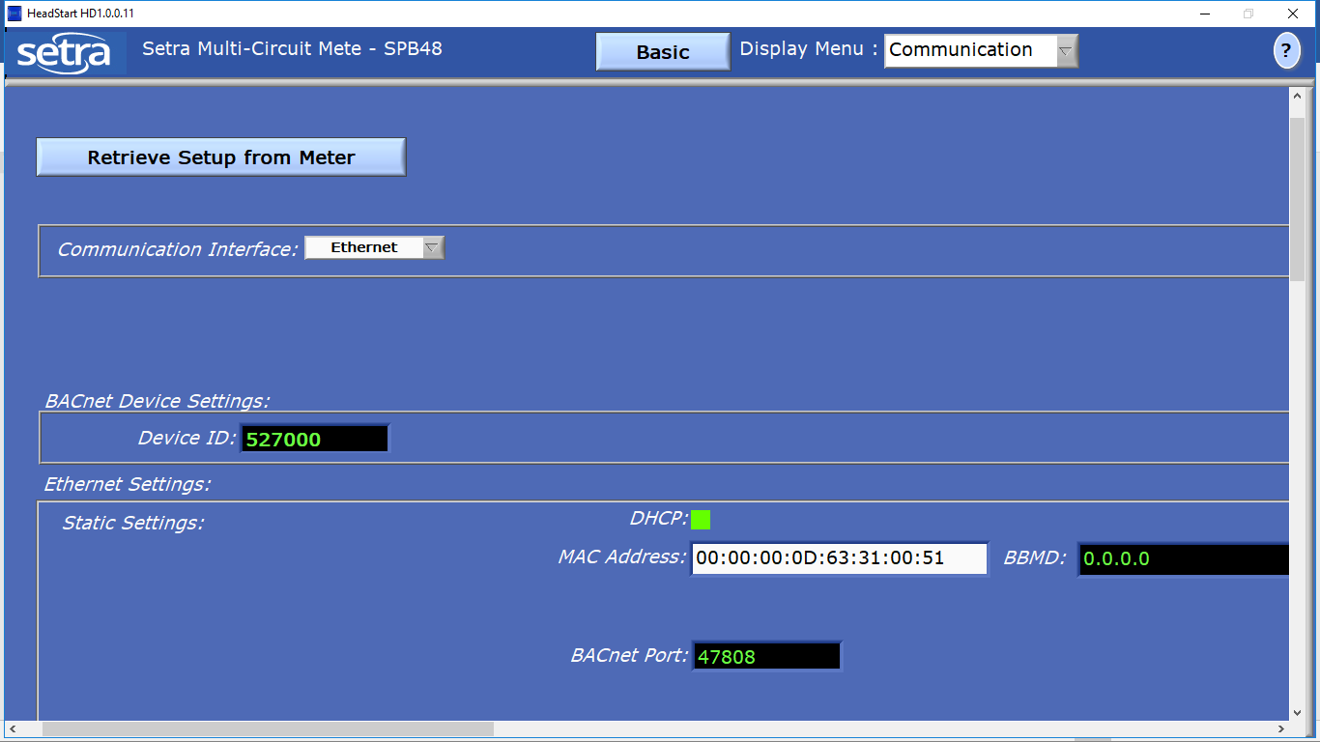

Basic > Advanced

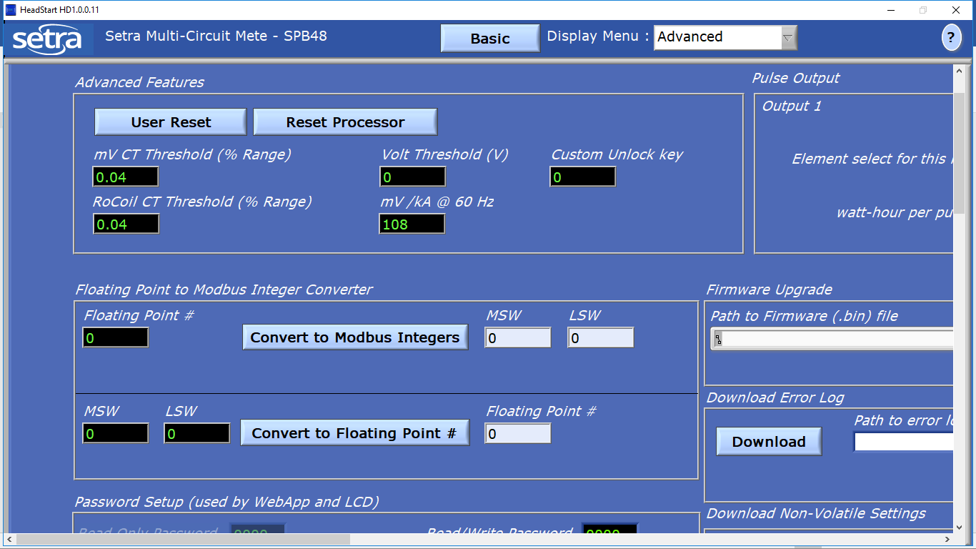

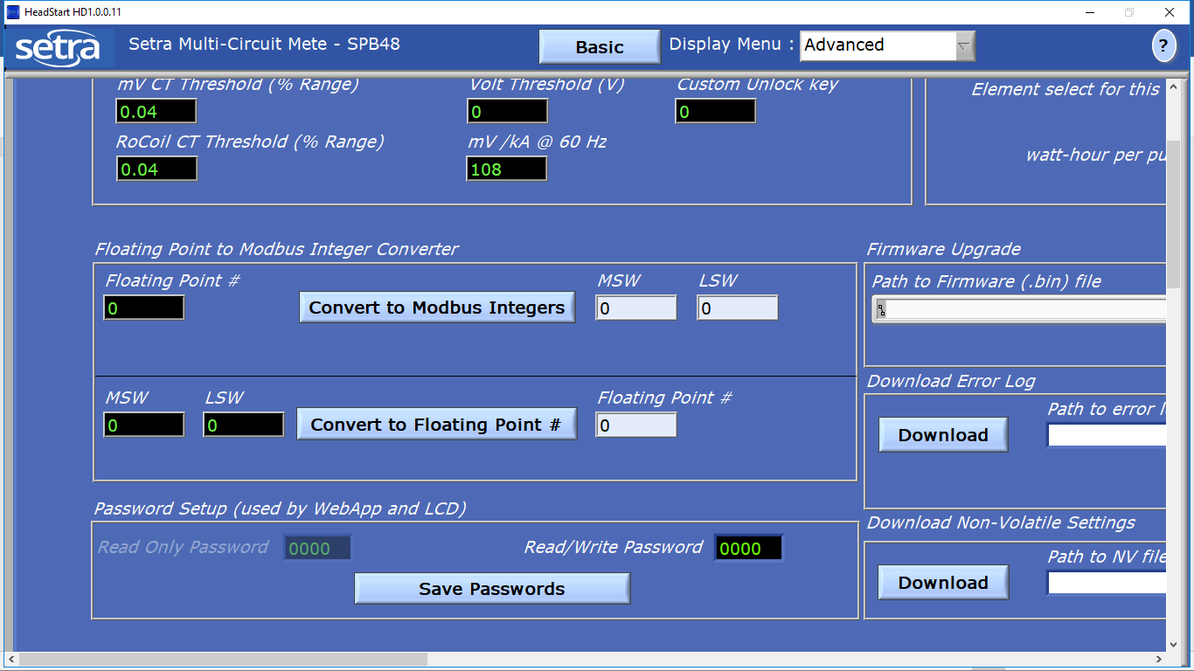

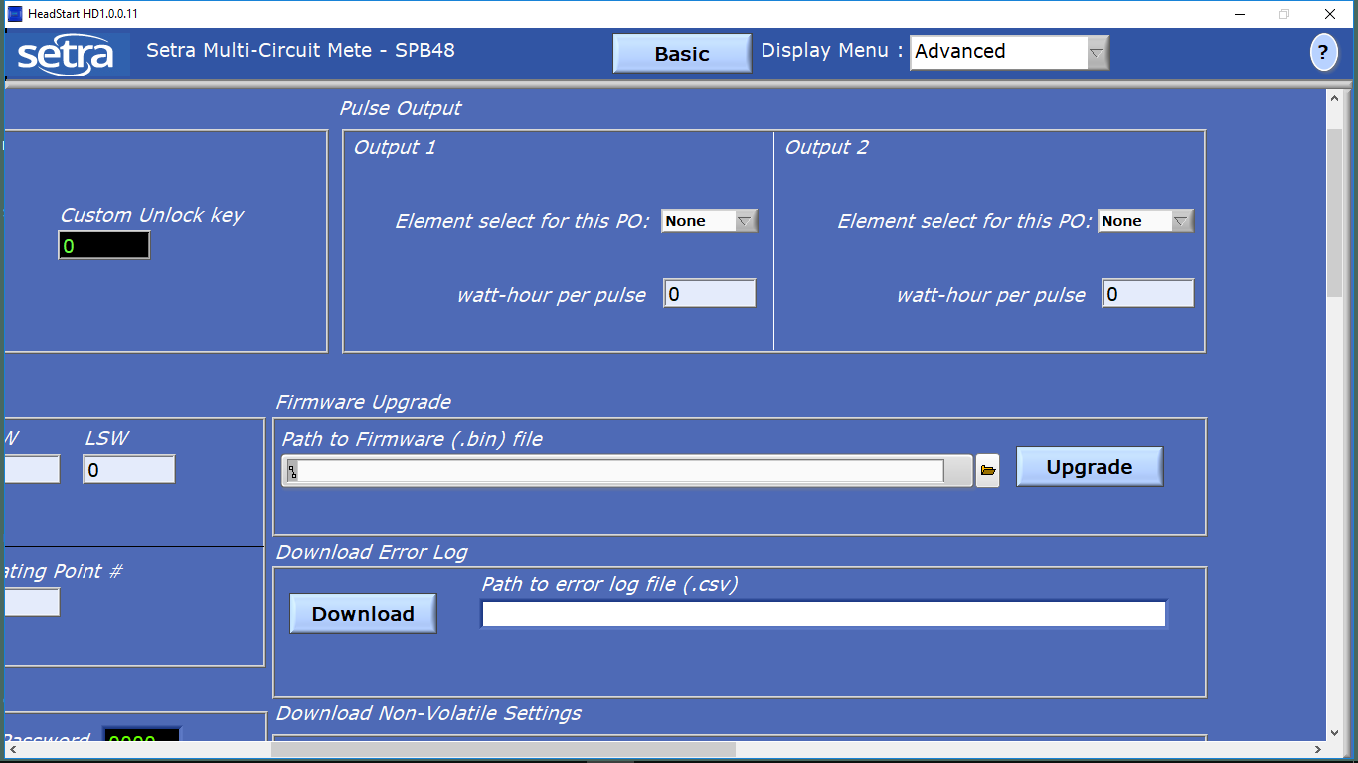

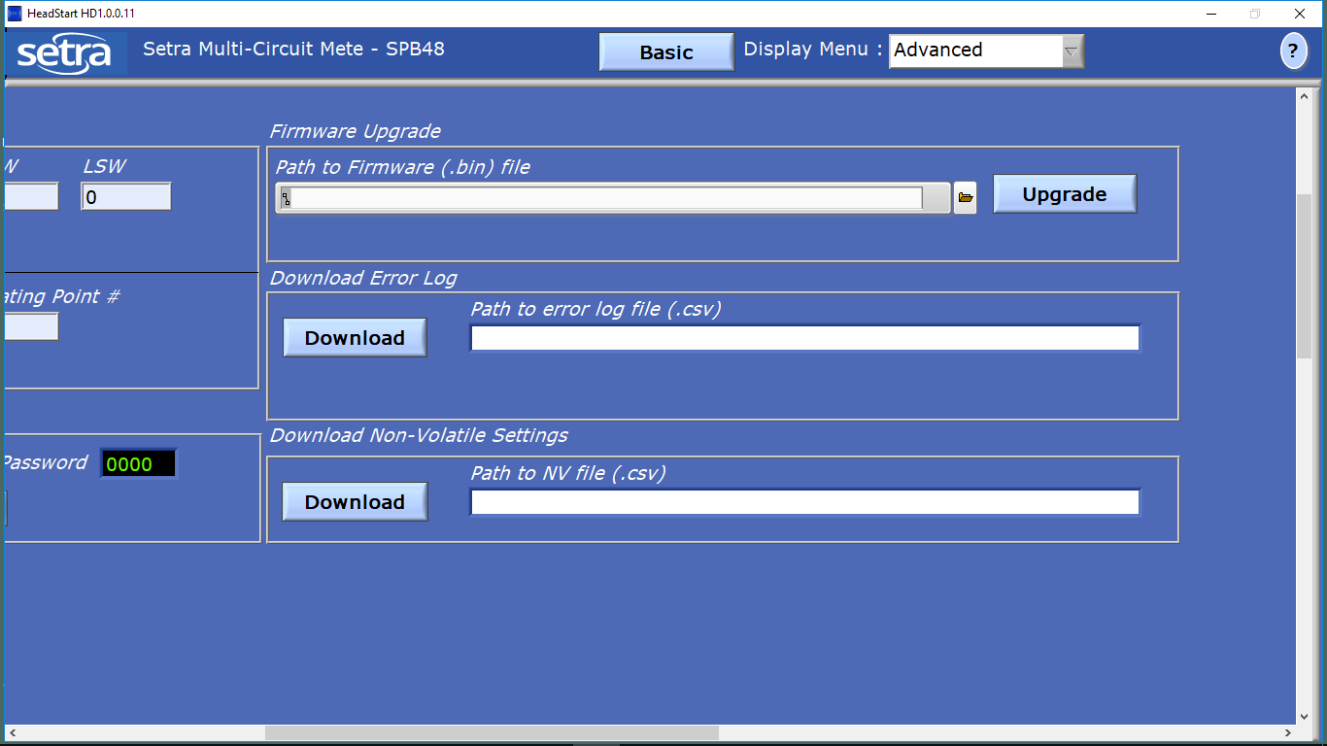

Basic > About

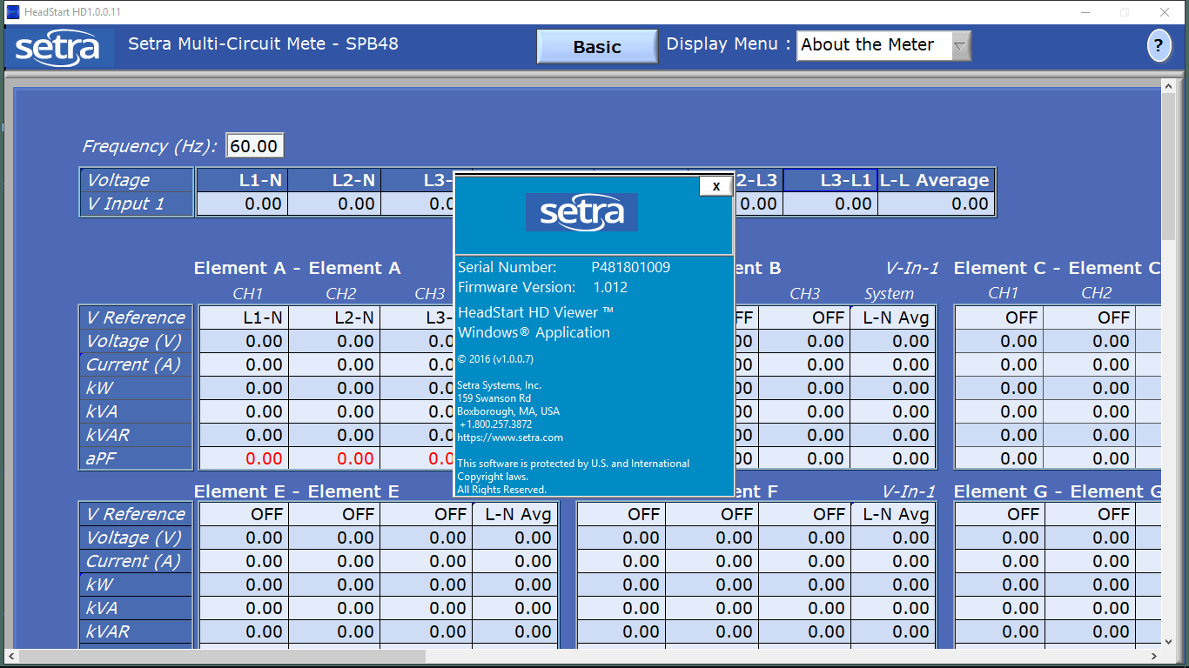

Extend > Power Factor

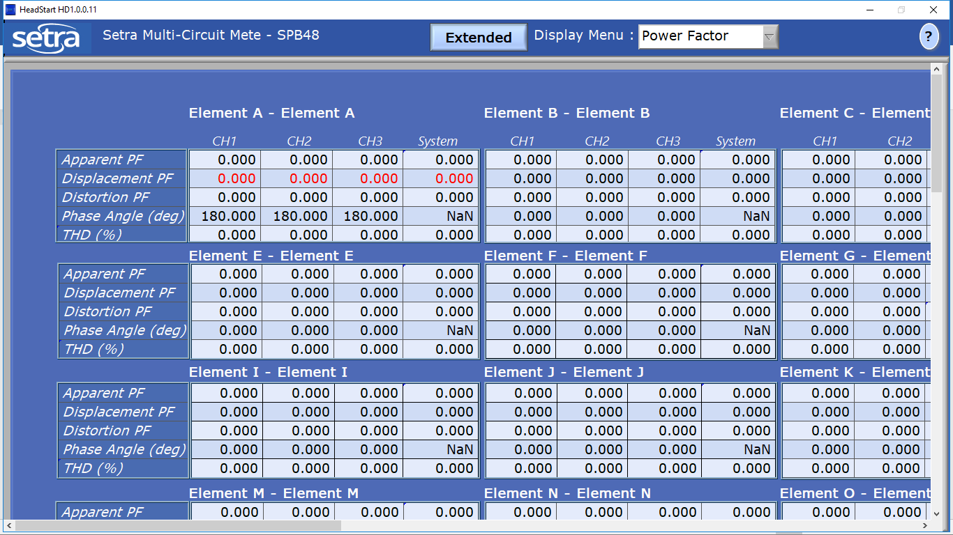

Extend > Waveform

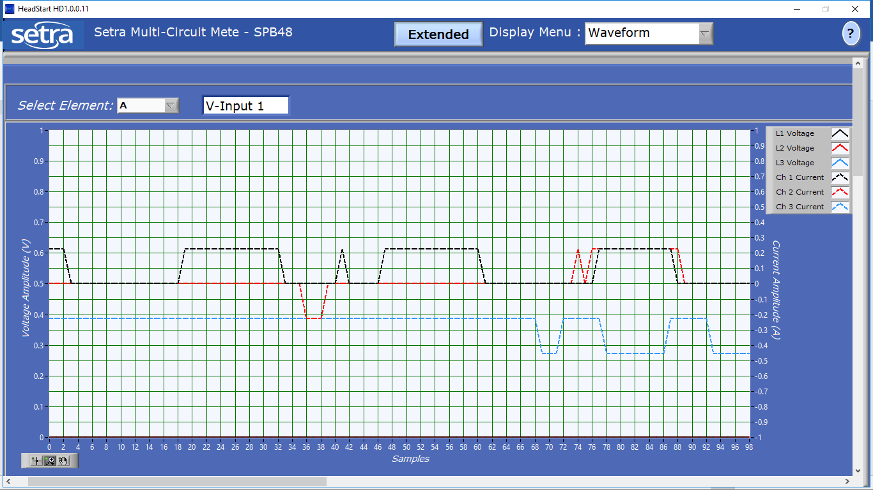

Extend > Harmonics

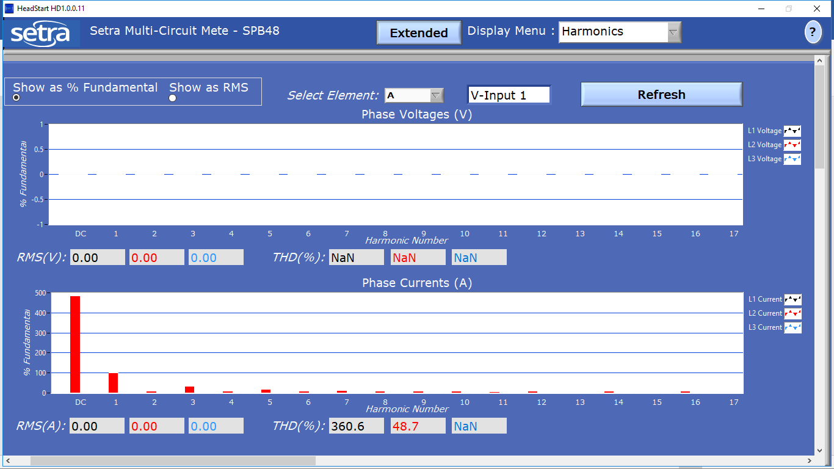

Extend > Phasor Plot

